**The Entrepreneurial Process**

**Assignment 3**

*Please answer all text questions in size 11 Arial font unbolded*

*Short answer to single paragraph length answers required*

*Places to write your answer indicated by “Answer: ”*

Questionnaire Contents:

* 7 Sections
  + Section 1: 4 Questions
  + Section 2: 8 Questions
  + Section 3: 6 Questions
  + Section 4: 4 Questions
  + Section 5: 2 Questions
  + Section 6: 2 Questions
  + Section 7: 1 Question

**Section 1: Details**

1. **What is your full name?**

Answer:

1. **What is your birthdate?**

Answer:

1. **What is the name of your business?**

Answer:

1. **Please provide some images for an infographic**
   1. **Picture of you:**

Answer:

* 1. **Picture of your business logo:**

Answer:

* 1. **Pictures of any promotional material you have for your business:**

Answer:

* 1. **Picture of your business location/place where you work (If able):**

Answer:

* 1. **Picture of your business card**

Answer:

**Section 2: How the entrepreneur demonstrates the entrepreneurial mindset and the ethical dilemmas the entrepreneur faced**

1. **Which of the three statements do you and your business identify with most?**

|  |  |
| --- | --- |
| **1. A new innovation on the current status quo** | **(I.E. Creating something brand new to the market)**  **(E.G. The invention of the car/internet)** |
| **2. Disrupting the current status quo of your industry** | **(E.G. Uber disrupting the taxi industry)** |
| **3. Harmonizing supply and demand** | **(E.G. Opening a coffee shop in a area where none exist and there is a demand for coffee)** |

Answer:

1. **Describe why you became an entrepreneur? (Specifically mention if it was for “Personal advancement”, “No alternative”, or “Independence”)**

Answer:

1. **Subsequently, do you identify as an opportunity-driven entrepreneur or necessity driven entrepreneur?**

Answer:

1. **Please select at least 3 of the following skills and give a quick example on how you demonstrated said skill**

|  |  |
| --- | --- |
| **Inner control** | **Decision making** |
| **Planning and goal setting** | **Human relations** |
| **Risk taking** | **Independence** |
| **Innovation** | **Reality perception** |
| **Use of feedback** |  |

Answer:

1. **Which of these statements describes you with your business? (Provide a 1-2 sentence reason for each you select)**

|  |
| --- |
| **You identify other people’s needs.** |
| **You build a product that meets those needs.** |
| **You repeat until you get it right.** |
| **You are intensely committed.** |
| **You have a determined perseverance.** |
| **You are optimistic.** |
| **You are burning with competitive desire.** |

Answer:

1. **Do you have a failure in your entrepreneurial journey that you learnt from? If so, what was it and what did you learn?**

Answer:

1. **Have you come across an ethical dilemma regarding your business? If so, what was it and how did you overcome it (If you did)?**

Answer:

1. **Do you identify as a social entrepreneur? (Act as an agent of change - identifying a social problem and using their entrepreneurial skills for social and environmental goals)**

Answer:

**Section 3: Pathway/Venture Process he/she took to start the business**

1. **How did you come up with the idea of your business?**

Answer:

1. **Why did you start this business venture?**

Answer:

1. **Which entrepreneurial opportunity best describes why you started your business?**

|  |  |
| --- | --- |
| **Want to compete with the existing businesses (Purchase low, sell high)** | **Became aware of a gap in the market** |
| **Want to Innovate (And disrupt existing markets)** | **Social Needs identified (Want to address the social problem)** |

Answer:

1. **Which of these best describes the pathway of your business?**

|  |  |
| --- | --- |
| **1.Bootstrapping** | **Used other people's resources.**  **Rely on networks and existing resources** |
| **2.Business assistance funding** | **Had access to aid in your venture.**  **E.g. financial funding, business information, training, mentoring** |
| **3.Miniprenurship** | **Started as a niche market and then expanded norm commerce** |
| **4.Classic start-up** | **Began because of one of the following (If so, which)**  **1.Satisfy untapped demand**  **2.Andance the product frontier**  **3.Lower prices**  **4.Broader market penetration**  **5.Drive less innovative products out of the market** |
| **5.Achquiring an existing venture** | **Obtained someone else’s business** |
| **6.Social venturing** | **Driven by the want to find solutions to social injustice or environmental problems** |

Answer:

1. **Please identify some key phases in the process you took to begin your business**

Answer:

1. **Did it follow this flow? (In some capacity)**

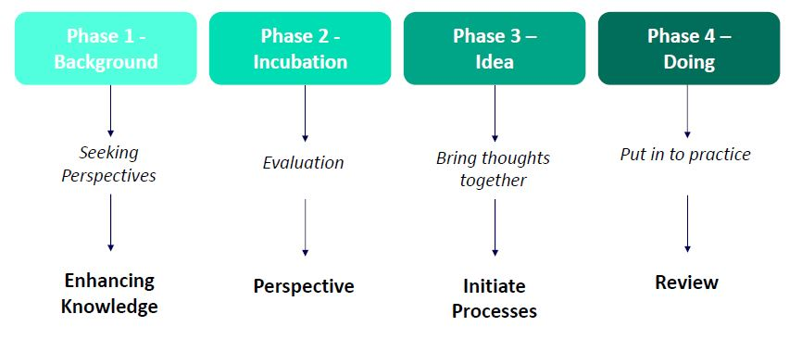

Answer:

**Section 4: How their business is innovative and helped the entrepreneur to be successful and why**

1. **Which best describes your business and its concept?**

|  |  |
| --- | --- |
| **1. Invention** | **Totally new product, service or process** |
| **2.Extension** | **New use or different application of existing product, service or process** |
| **3.Duplication** | **Creative replication of an existing concept** |
| **4. Synthesis** | **Combination of existing concepts and factors into a new formulation or use** |

Answer:

1. **Describe how your business fits the category selected in question 1 of Section 4**

Answer:

1. **In your own words, how is your business innovative?**

Answer:

1. **How has your business helped you to become successful?**

**Section 5: What opportunities did the entrepreneur perceive and exploit to develop their business in relation to the forces in the competitive environment**

1. **What hole in the market did you see that your business fills?**

Answer:

1. **How is your business different from its competitors? (How does it stand out)**

Answer:

**Section 6: Funding sources they obtained**

1. **What sources of income did your business obtain? (E.g. Self funded, investors, government loans)**

Answer:

1. **How did you obtain said income sources?**

Answer:

**Section 7: Different approaches**

1. **Is there anything you would've done differently in your business venture? Looking in retrospect. If so, what?**

Answer: